Balancing your ideas and your sources

Too much information from sources

You can use a variety of techniques to negotiate the price of a used car (Wilfred, 2004).  One method is called the broken record technique: "No matter what the salesperson says, you just keep repeating, 'I want to pay no more than $X for this car.'  By repeating yourself like a broken record, you wear the salesperson down" (Wilfred, 2004, p. 12).  Another method is the signed-sealed-delivered technique: "When you use this technique, you tell the salesperson, 'I will sign the contract as soon as you agree to the price I think is fair for the car'" (Wilfred, 2004, p. 12).  A third technique focuses on mutual respect and finding a price that is fair to both the buyer and the seller (Wilfred, 2004).  After all, "a car is a major investment, and you have to plan not only for the purchase price but also the cost of upkeep and maintenance" (Browning, 2016, p. 40).

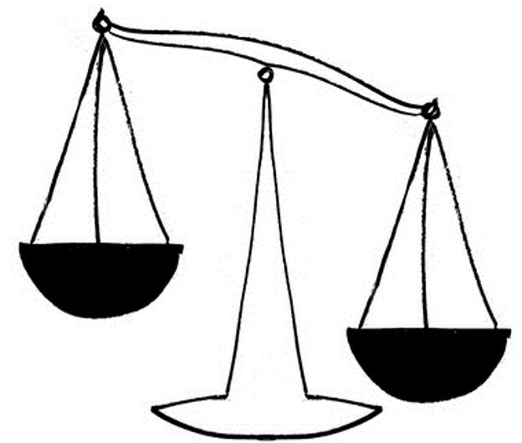

You can use a variety of techniques to negotiate the price of a used car.

One method is called the broken record technique: "No matter what the salesperson says, you just keep repeating, 'I want to pay no more than $X for this car.'  By repeating yourself like a broken record, you wear the salesperson down."

Another method is the signed-sealed-delivered technique: "When you use this technique, you tell the salesperson, 'I will sign the contract as soon as you agree to the price I think is fair for the car.”

A third technique focuses on mutual respect and finding a price that is fair to both the buyer and the seller.

After all, "a car is a major investment, and you have to plan not only for the purchase price but also the cost of upkeep and maintenance."

**Information from   
sources**

Your ideas

**MORE**

**The right balance between your ideas and information from sources**

When you are shopping for a used car, you can use several techniques to make sure you don't exceed your budget. As sales expert Gary Wilfred (2004) tells us, "One highly successful technique is called *the broken record*. No matter what the salesperson says, you just keep repeating 'I want to pay no more than $X for this car.'  By repeating yourself like a broken record, you wear the salesperson down" (p. 12). A second technique takes advantage of the desire that salespeople have to make a sale. With this technique, called *signed, sealed, delivered,* you agree to sign the contract as soon as the salesperson meets your price (Wilfred, 2004). A third technique is based on making sure that both you and the salesperson benefit from the sale. You tell the salesperson that you want a price that helps her make a reasonable profit while not exceeding your own budget (Wilfred, 2004).

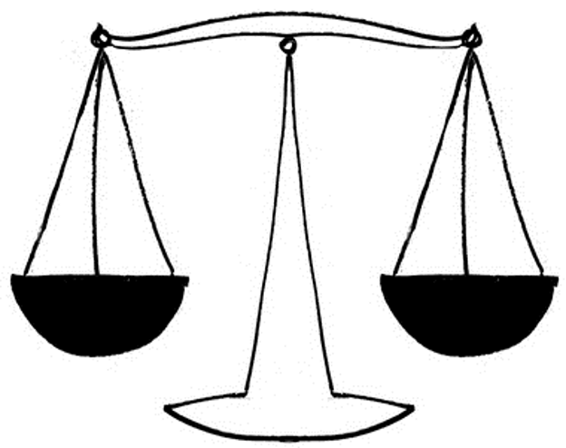

As sales expert Gary Wilfred tells us, "One highly successful technique is called *the broken record*. No matter what the salesperson says, you just keep repeating 'I want to pay no more than $X for this car.'  By repeating yourself like a broken record, you wear the salesperson down.”

A third technique is based on making sure that both you and the salesperson benefit from the sale.

When you are shopping for a used car, you can use several techniques to make sure you don't exceed your budget.

A second technique takes advantage of the desire that salespeople have to make a sale.

You tell the salesperson that you want a price that helps her make a reasonable profit while not exceeding your own budget.

With this technique, called *signed, sealed, delivered,* you agree to sign the contract as soon as the salesperson meets your price.

Your ideas

**Information from sources**